Transfer Files
Transfer Files operation is used to keep the defined data in the current financial year and the customers’ balances and accounts, and move them to the new financial year, which make it easy to work and link between the different financial year of the company.
Also, through Transfer Files, you can control the data you want to be transferred, and make a data backup before the transferring to keep the file out of any error it may occur during the transferring, also you can control the currency you want to depend in transferring, and make balance and accounts checking.
The initial steps before balance transferring and prepare the statements:
- Prove the allowances generally, and the debt allowance and the doubtful debts if necessary.
- Prove the exchange price differences.
- Match the balances with customers and suppliers.
- Make inventory and prove the inventory adjustments.
- Assets inventory and prove the depreciations.
- Prove the expenses and the presented and due incomes.
- Cash inventory (cash in hand and banks).
Tools | Transfer Files
This window can be reached:

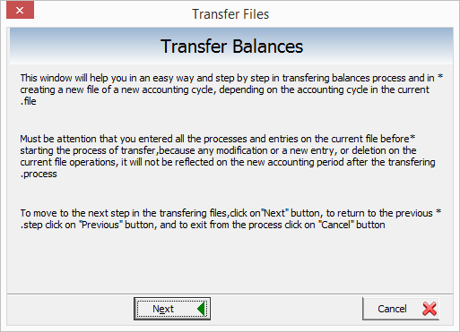

Through this window, you can start transfer balances and the existing accounts during the current financial year to the next financial year, where all of the accounts balances will be transferred according to their balances during the current year, also, you should be careful to enter the data correctly during the whole financial year, any transferring operation that is done on the balances and the accounting process of the current year, the accounting process in the next financial year will not be affected with.
A whole intact file transferring will not be transferred if there are any errors in the accounts of the current financial year, so you should be careful to the operations and prices checking.
After reading the contents of this window, you can move to the next window through Next button, or undo the process through Cancel button.
After clicking on Next, the following window appears:
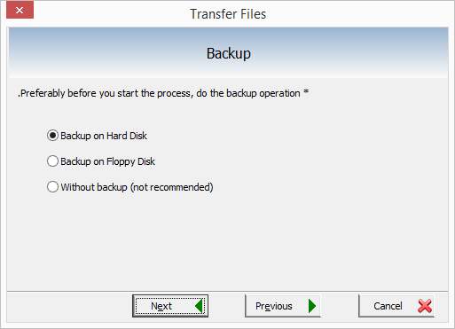
Through this window, you present many options to the user by save the current files, thus make a backup to keep the data safe during the current year.
You can make use of this window to keep the data save and errors free from the user, since the begging of transferring, it’s necessary to make a backup on the hard disk.
This window contains:
- Backup on the hard disk: when you activate this option, a backup of the current data will be generated on the hard disk.
- Backup of floppy disk: when you activate this option, a backup of the current data will be generated on the floppy disk.
- Without a backup: when activate this option, you can move to the next stage to the transferring without make a backup, but it’s recommended to make a data backup.
When you choose to make a backup, a backup window appears:
Through this window, you can add a specific piece of information to distinguish the backup you want to make, to make it easy to restore according to the user’s wish.
When you click on Ok, a data backup is done, and you move to the next stage of transferring.
After backing up is done, balance transferring appears:
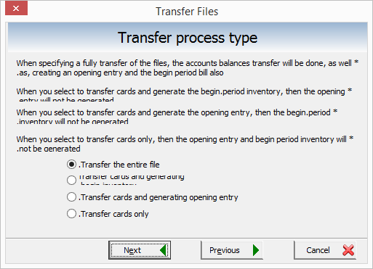
The balances transferring window is used to select the transferring type that you want to make, contains many options:
- Transfer the entire file: when activating this option, all of the file cards and the accounts balances will be transferred, opening entry and the beginning inventory will be created.
- Transfer cards and generate the opening entry: when activating this option, the cards will be transferred to the new financial year, but the beginning inventory will not be generated.
- Transfer cards only: when activating this option, the cards will be transferred to new financial year, but the opening entry and the beginning inventory will not be generated.
When choosing the Previous button, you return to the previous window, when you select Next, you move to the next stage of transferring:
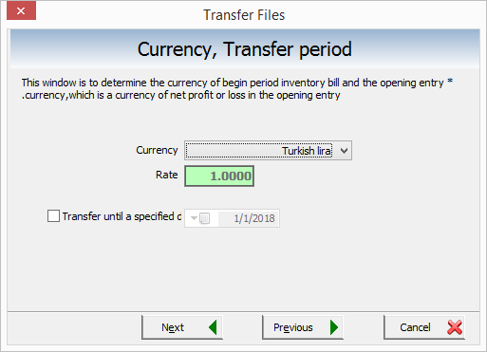
This window is used to select the currency of the new file, you can select the currency of the beginning inventory that will be generated automatically after finishing the file transferring to the next financial year.
This currency will be considered the currency of the opening entry which will be generated automatically too, when selecting a currency other than the main currency of the current file, the rate of this currency to with the main currency appears in the rate field.
When clicking on Previous, you return to the previous window, when clicking on Cancel, you undo to the transferring.
When you click on Next, you move to the next window:
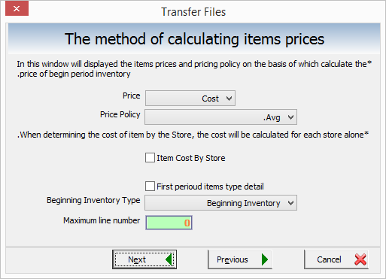
This window is used to select the type of items prices that will be transferred during the transferring process, thus, the prices in which the beginning inventory will be calculated with after the transferring.
Items prices window contains:
- Price: through the menu, you can select the required price for the beginning inventory to be calculated with.
- Pricing Policy: when you select the cost price from prices list, one of the prices policy from this window.
- Item cost by store: when activate this option, the item cost price will be calculated by the store.
- The beginning inventory types detailing: when activating this option, the beginning inventory type option will be deactivated.
When you click on previous, you return to the previous window, when you click on Cancel, you undo the transferring.
When you click on Next, you move to the next window:
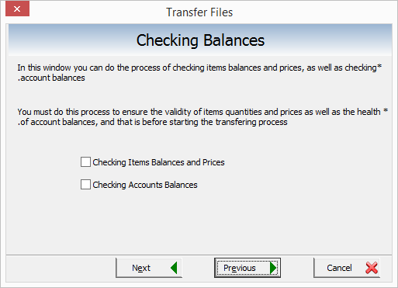
This window is used to check the item prices and their quantities, and checking the accounts balances that existed in the current file to be transferred correctly to the next financial year file.
Checking Balances window contains:
Checking items balances and prices: when activating this option, the items quantities in the stores and their prices will be checked.
Checking Accounts Balances: when activating this option, the existing accounts balances in the current file will be checked to avoid any error during transferring.
When clicking on previous, you return to the previous window, when you click on Cancel, you undo the transferring.
When you click on Next, you move to the next window:
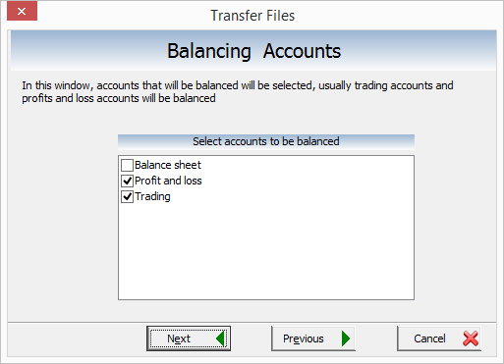
This window is used to select the accounts you want to be balanced to the next financial year, usually the trading and the profits and loses accounts will be balanced, through this window, all of the accounts except of the budget will be selected according to the user’s wish.
When you click on previous, you return to the previous window, and when you click on Cancel, you undo the process.
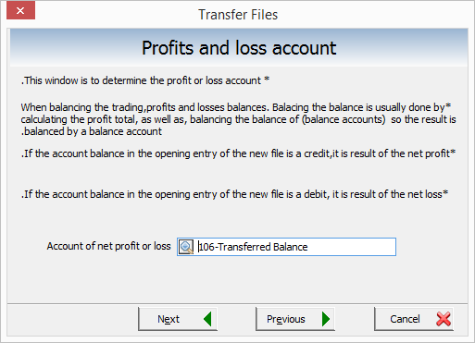
When you click on Next, you move to a warning window:
Through this message, the user is warned to negative items in the file, these items will be saved in a text file. When you click on Previous, you return to the previous window, when you click on Cancel, you undo the transferring.
When you click on Next, you move to the next window:
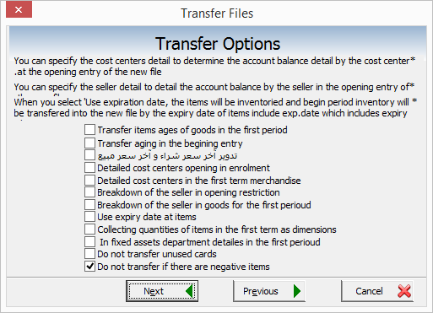
Transferring options window is used to control the transferring method you want to do, which contains the following options:
- Detailing the cost centers in the opening entry: when activating this option, the accounts balances will be detailed in the opening entry in the new file by cost centers.
- Detailing the cost centers in the beginning inventory: when activating this option, the beginning inventory in the new file will be detailed by the cost centers.
- Detailing the salesman in the in the beginning inventory: when activating this option, the beginning inventory in the new file will be detailed by the salesman.
- Use expiration date in the items: when activating this option, item inventory will be made, and the beginning inventory in the new file according to the expiration date of the items that has expiration date.
- Collect the items quantities in the beginning inventory by dimensions: when activating this option, the beginning inventory by dimensions.
- In fixed assets, detailing the departments in the beginning inventory: when activating this option, the departments will be detailed in the beginning inventory.
- Do not transfer if there are negative items: when activating this option, the transferring operation won’t be done if there are negative items in the current file.
When you click on previous, you return to the previous window, when you click on cancel, you undo the transferring.

When you click Next, you move to the next window:
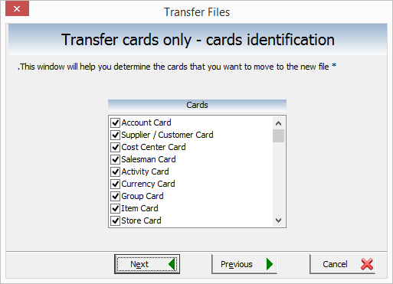
This window is used to select certain cards from the program cards, to be transferred to the next new financial year, where you can control the cards you want to be transferred only.
When you click on Previous, you return to the previous window, cancel to undo the transfer.
When you click on Next, you move to the next window:
It’s used to view the beginning inventory accounts and the related store, and the branch and cost center appears.
When clicking on previous, you return to the previous window, cancel to undo the transferring.
When clicking on Next, you move to the next window:
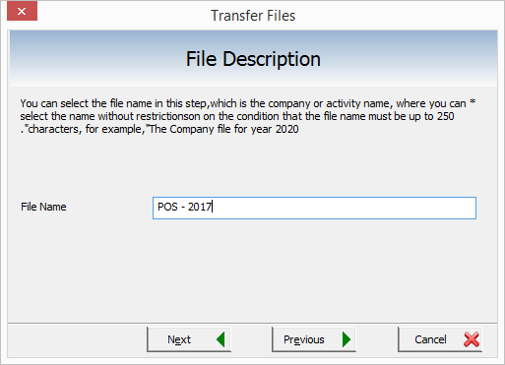
This window is used to select a special name of the new file according to the user’s wish, it’s possible to be (the company name or the work owner).
When you click on Previous, you return to the previous window, cancel to undo the transferring.
When clicking on Next, you move to the next window:
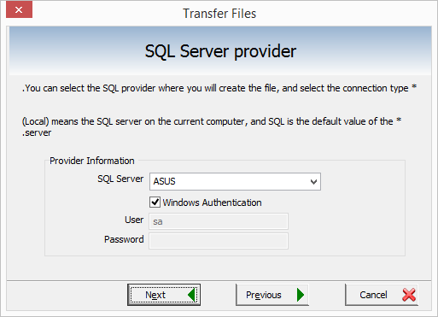
This window contains many fields about the server:
SQL Server: select the server name (PC) depending on the server name you selected during SQL installation in the PC, these settings are related to SQL installation settings.
Windows authentication: this field is activated if it was typed during SQL installation, this option will be chosen in SQL if you need to use this PC as a server to let many devices connect to it.
SQL user: select the user name (these settings are related to SQL installation settings).
Password: select a password, if you type it during the SQL installation.
When you click on previous, you return to the previous window, cancel to undo the transferring.
When you click on Next, you move to the following window:
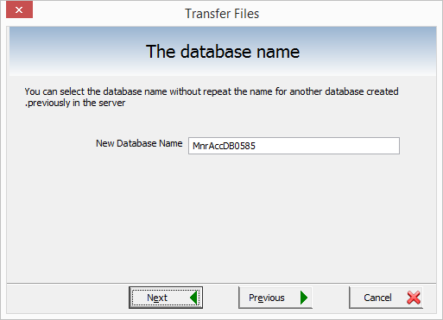
This window is used to rename the file database you want to create in the program, as long as it’s not repeated in another database (for example MnrAccDB0585)
When clicking on Previous, you return to the previous window, cancel to undo the transferring.
When clicking on Next, you move to the next window:
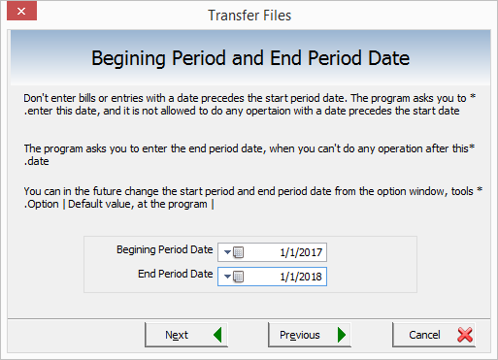
This window is used to specify the beginning period, thus the beginning of creating the file, they’re the arithmetic operations in the company, the beginning date cannot be a date prior to the current date, and cannot add a bill or entry in the program before the date of the period beginning selected in the window or after the date of the ending of the selected period in the window, and you can change the beginning and the ending period through the tools menu – options – default values.
When you click on previous you return to the previous window, cancel to undo the transferring.
When clicking on Next, you move to the next window:
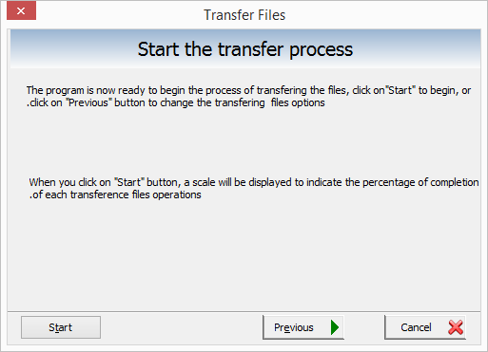
After selecting the transferring options, and selecting the cards you want to transfer and other options, and select the new file name, currency, … etc. starting the transferring window appears, through this window, the actual transferring will begin to transfer the current file to the new file in the new financial year.
When you click on Previous, you return to the previous window, cancel to undo the transferring.
When you click on Next, you move to the following window:
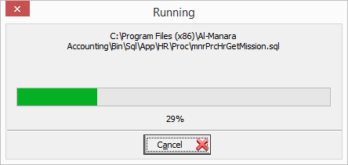
It’s the final step in transferring process, meanwhile, a new file is being created.
After that, the transferred file becomes ready to add items, accounts, groups and make the required arithmetic operations.

When you click on Next button, creating files is finished, a window indicates that the process is done appears, and the required file has been created.
After clicking on OK, login window appears:
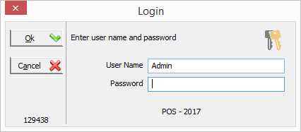
Through this window, you type user name and password of the file, when you click on OK, you confirm the name, cancel to exit the window ad return to the current file.
After that, you can login to the new file, and complete the arithmetic operations as in the previous year.
Notes:
- You must select the beginning inventory account as trading in the bill types – beginning inventory to complete the transferring.
- The transferring is dangerous operation, you should be careful when you are doing it, it’s better to make a backup before starting.
- Before transferring, you must select the beginning inventory account and the ending inventory account in bill types.
-------------------------------------------------------------------------------------------
All rights reserved for Al-Manara Management Information Systems LLC © 2006-2017
For more information, email us on feedback@almanarasoft.com – www.almanarasoft.com

